Creating a BD™ AbSeq assay reference file
- Using a text editor, such as Notepad on Microsoft® Windows®, TextEdit on macOS®, or Sublime Text, open the BD AbSeq master reference file. Do not use Microsoft Word or any other word processor.
The master reference file can be downloaded from this link, or from the BD Single Cell Genomics Analysis Setup User Guide, Doc ID 47383. Contact us at SCOMIX@bd.com for a copy of the file if you run into any issues with the download. The following is an example of the master file opened in Sublime Text editor.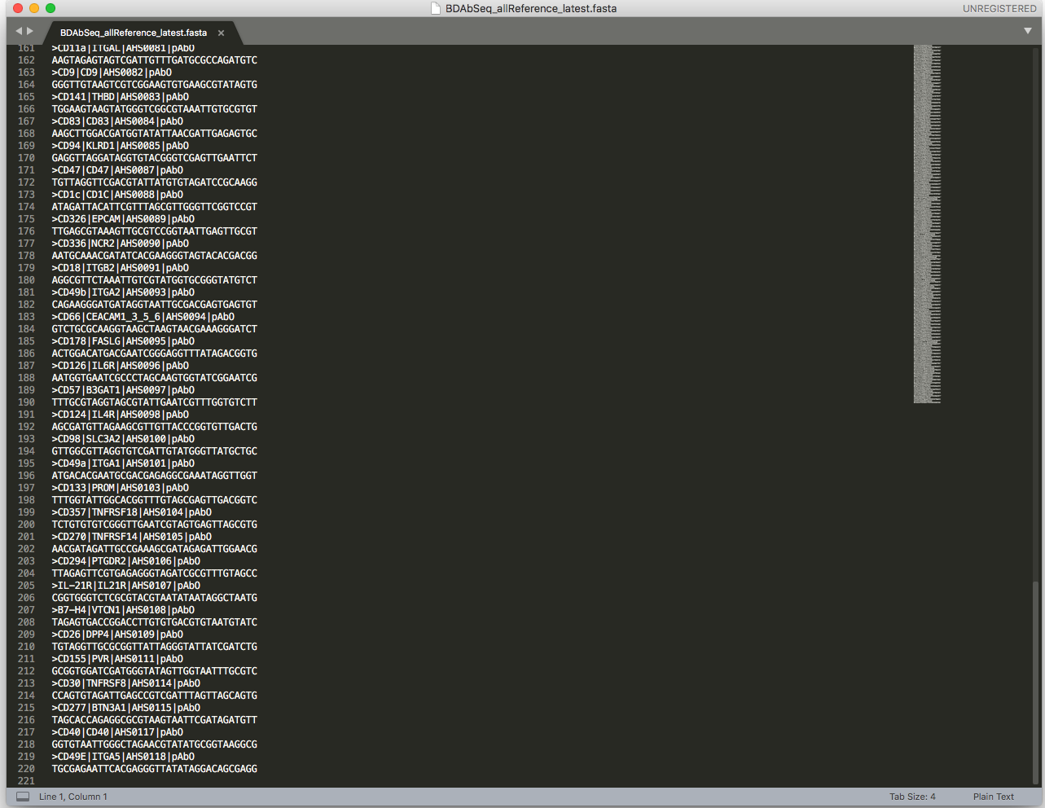
- Open a new file in the text editor and save it with the extension .fasta. The following screenshot shows a sample title of AbSeq_reference.fasta. 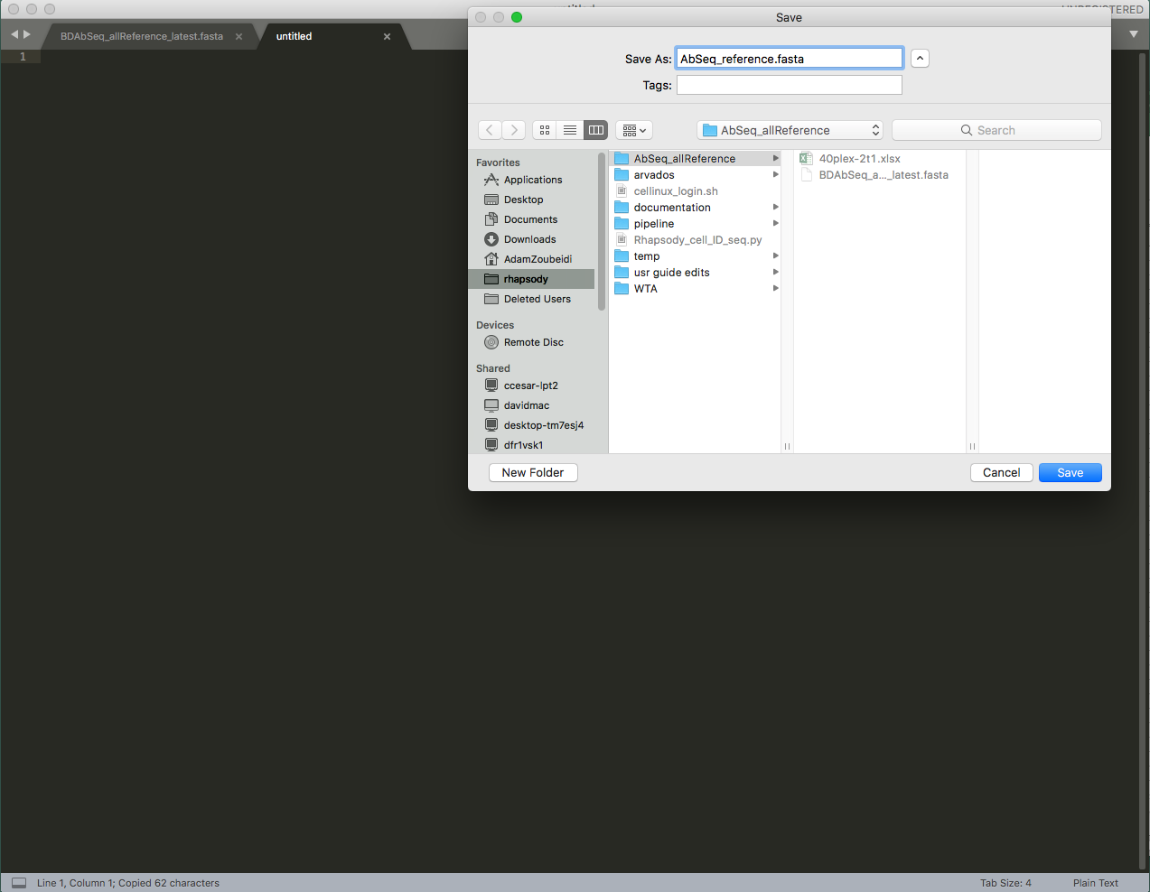

- Locate each BD AbSeq file used in the experiment within the master list. Copy the full header line (starting with >) and its barcode sequence from the master list into the newly created .fasta file. The following example shows 20 AbOligos used. 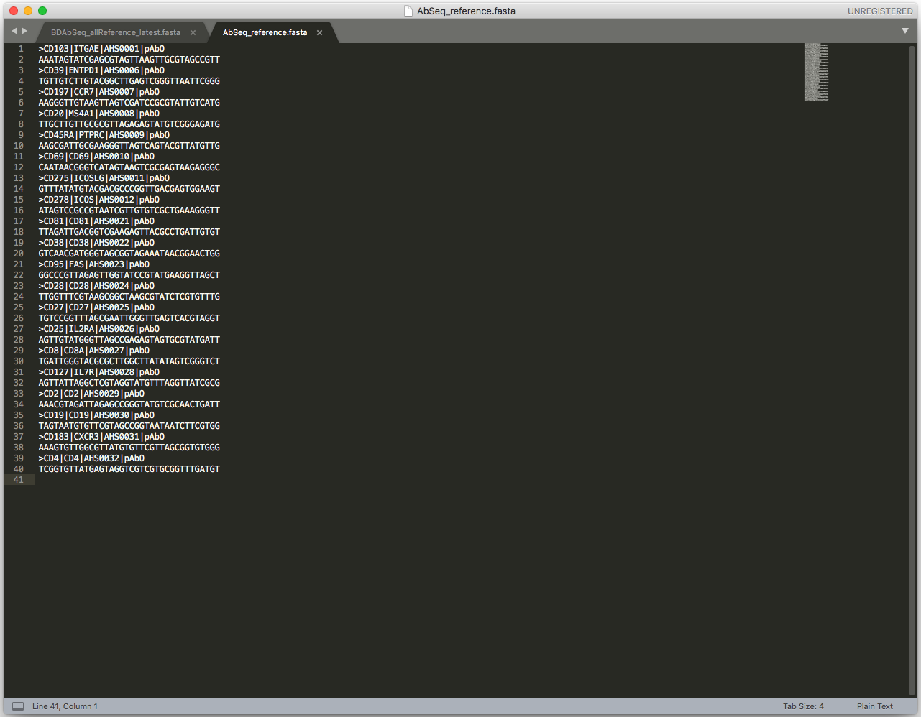
- If custom sequences were used, add the antibody name to the header of the custom sequence to correspond with your targets.

The custom sequence in the reference file has no target associated with it and looks like this:
>ACU7001|pAbO
TTGCGATAGGTTACCAGGATGTGCGGATAGTTACTT

Add the target immediately after the “>” character and insert a vertical bar, “|” immediately after like this:
>CD1234|ACU7001|pAbO
TTGCGATAGGTTACCAGGATGTGCGGATAGTTACTT

This ensures that CD1234 will show up in the output files of the pipeline.

For Research Use Only. Not for use in diagnostic or therapeutic procedures.
Trademarks are the property of their respective owners.
Becton, Dickinson and Company, BD Biosciences, San Jose, CA, 95131, USA
© 2019 BD. All rights reserved. Unless otherwise noted, BD, the BD Logo and all other trademarks are property of Becton, Dickinson and Company.

